
MERU UNIVERSITY OF SCIENCE TECHNOLOGY

DEPARTMENT OF ELECTRICAL AND ELECTRONICS ENGINEERING
BACHELOR OF TECHNOLOGY IN ELECTRICAL AND ELECTRONICS ENGINEERING
LAB REPORT: STATE SPACE MODELLING
https://github.com/joshuawambua/controlsystems.git
UNIT CODE: EET 3407
UNIT DESCRIPTION: CONTROL SYSTEMS II.
NAME: JOSHUA MUTHENYA WAMBUA
REG NO: EG209/109705/22
Instructor: Dr. Agnes
Date: 14/12/2025

TABLE OF CONTENTS
1. Introduction 1
2. Objectives 1
3. Materials and Resources Used 1
Fig 1. The DC motor Being modelled 2
4. Results 2
Fig 2. Matlab screenshot for the simulation. 7
5. Discussion & Assignment 8
5.1 Meaning of a State Variable 8
5.2 Preference of State-Space Modelling over Transfer Function Modelling 8
5.3 Physical Significance of the State and Output Equations 8
5.4 Additional Discussion 8
6. Conclusion 9
7. References 9

1. Introduction
State-space modelling is a fundamental technique in modern control systems used to represent dynamic systems using a set of first-order differential equations. Unlike classical transfer function approaches, state-space representation allows direct incorporation of initial conditions, multiple inputs and outputs, and internal system dynamics. This approach provides a structured and systematic framework for system analysis and controller design. In this laboratory exercise, the principles of state-space modelling are studied theoretically in order to understand system dynamics, stability, controllability, and observability.

2. Objectives
- To understand the concept of state variables and state-space representation.
- To formulate state-space models from given system equations.
- To analyze system behavior using state and output equations.
- To understand the significance of the state transition matrix and system stability.
- To explore controllability and observability of a system.

3. Materials and Resources Used
- Lecture notes on state-space modelling
- Control systems textbooks and reference materials
- Pen, paper, and calculator for analytical derivations
- MatLab for simple scripting.

This modeling involved a DC motor
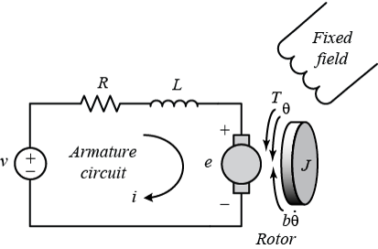

Fig 1. The DC motor Being modelled

4. Results
The lab exercise was based on theoretical analysis. The results are presented in analytical form rather than simulation outputs. Appropriate state variables were defined and used to express system dynamics in state-space form. General state and output equations were obtained, clearly demonstrating how dynamic systems can be represented using matrix equations.
Key system properties such as controllability, and observability were identified through inspection and analytical evaluation of the derived state-space equations.
The GitHub repository provided on the cover page has the maltab script and other resources.
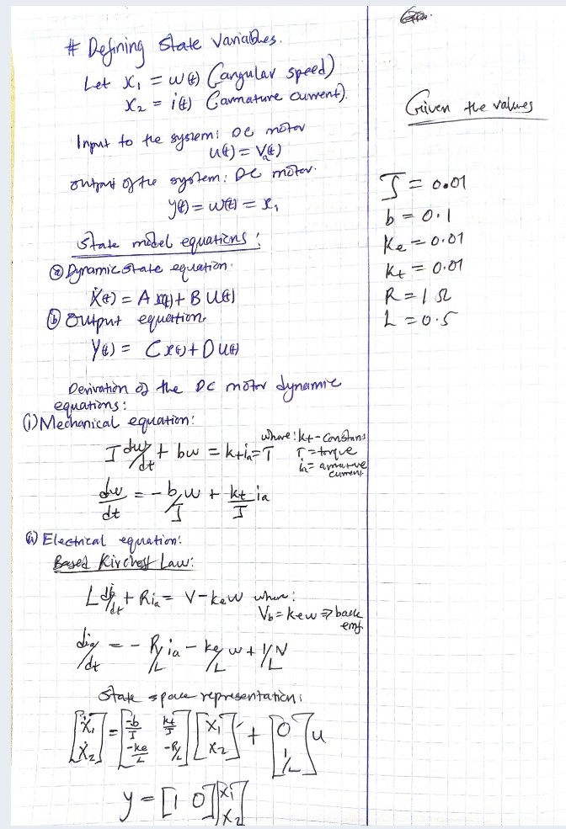
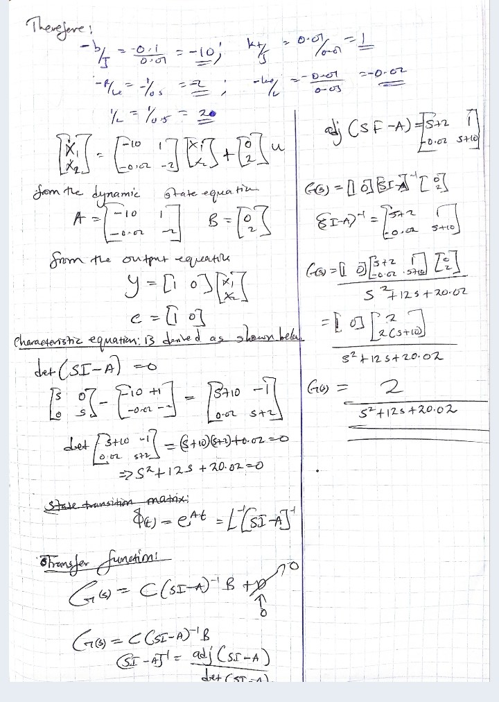
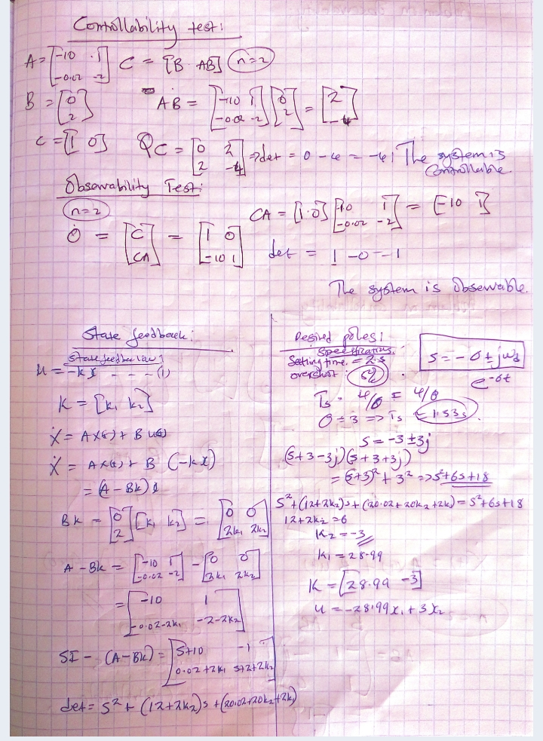

Below is Simple Matlab Scripts To Further Analyse The System

% Physical parameters
J = 0.01; % kg.m^2
b = 0.1; % N.m.s
Ke = 0.01; % V/(rad/s)
Kt = 0.01; % N.m/A
R = 1; % Ohm
L = 0.5; % Henry
% State-space matrices
A = [-b/J Kt/J;
-Ke/L -R/L];

B = [0;
1/L];

C = [1 0]; % Output = motor speed
D = 0;

% Create state-space system
sys = ss(A,B,C,D);
% Time vector
t = 0:0.01:5;

% Open-loop step response
figure;
step(sys, t);
grid on;
title('Open-Loop Step Response of DC Motor Speed');
xlabel('Time (seconds)');
ylabel('Angular Speed (rad/s)');
% Desired closed-loop poles
p = [-3+3i -3-3i];

% State feedback gain
K = place(A,B,p);

% Closed-loop system
Acl = A - B*K;
sys_cl = ss(Acl,B,C,D);

% Closed-loop step response
figure;
step(sys_cl, t);
grid on;
title('Closed-Loop Step Response with State Feedback');
xlabel('Time (seconds)');
ylabel('Angular Speed (rad/s)');
% Controllability
Co = ctrb(A,B);
rank_Co = rank(Co)

% Observability
Ob = obsv(A,C);
rank_Ob = rank(Ob)

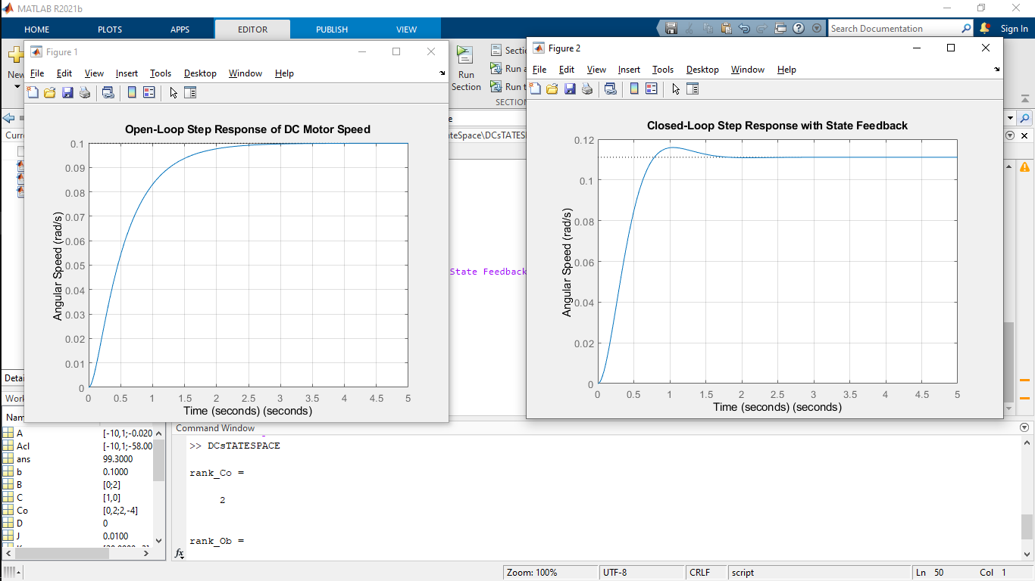

Fig 2. Matlab screenshot for the simulation.

5. Discussion & Assignment

5.1 Meaning of a State Variable
A state variable is a variable that represents the internal condition of a dynamic system. A complete set of state variables contains sufficient information such that, together with the system input, the future behavior of the system can be uniquely determined.

5.2 Preference of State-Space Modelling over Transfer Function Modelling
State-space modelling is preferred for complex systems because it can handle multiple-input multiple-output (MIMO) systems, directly incorporate initial conditions, and represent nonlinear or time-varying systems. Furthermore, it provides a suitable framework for modern control techniques such as state feedback control, observer design, and optimal control.

5.3 Physical Significance of the State and Output Equations
The state equation describes how the internal state variables of the system evolve over time under the influence of system inputs. The output equation relates these internal state variables to the measurable outputs of the system.

5.4 Further Discussion
State-space modelling provides deeper insight into system dynamics compared to classical methods. By working directly with state variables, engineers can systematically analyze stability, controllability, and observability. Although simulations were not performed in this exercise, the analytical formulation provides a strong foundation for future implementation using tools such as MATLAB/Simulink and for real-world control system applications.

6. Conclusion
This laboratory exercise provided a clear understanding of state-space modelling and its importance in control system analysis and design. Through theoretical formulation, the relationships between system dynamics, state variables, and outputs were established. The exercise highlights the relevance of state-space methods in modern engineering applications, particularly in systems that require advanced control strategies.

7. References
- Ogata, K., Modern Control Engineering, Prentice Hall.
- Nise, N. S., Control Systems Engineering, Wiley.
- Dorf, R. C., and Bishop, R. H., Modern Control Systems, Pearson.

